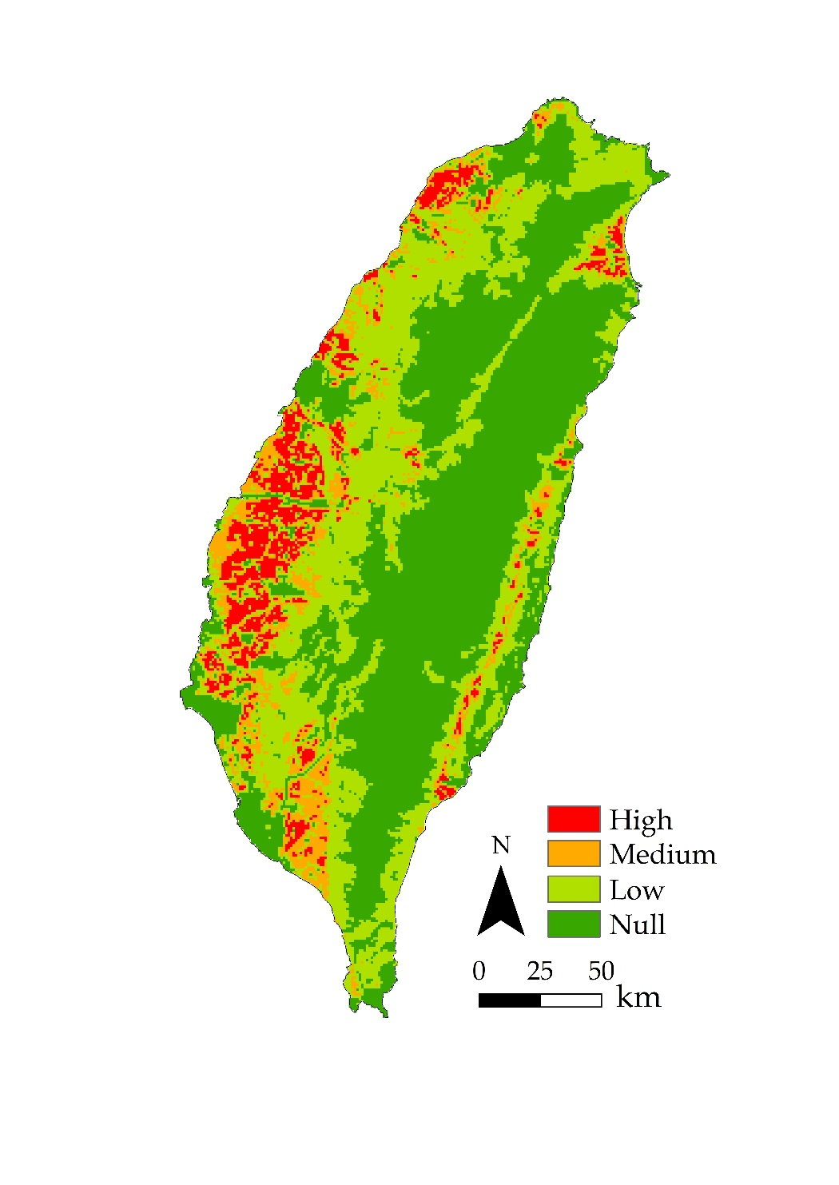
補充圖1. 研究區農業生產價值分級圖
Fig. S1. Level of agricultural production in study area.

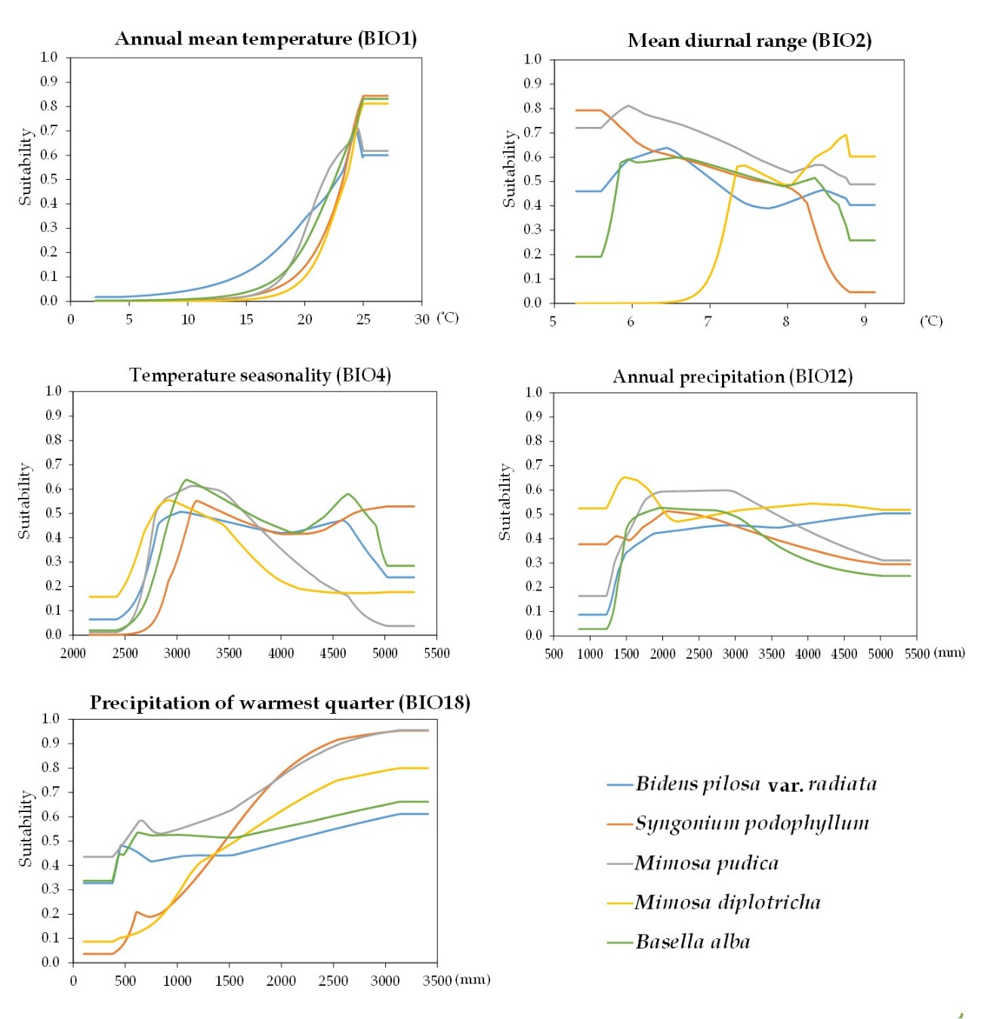
補充圖2. 入侵雜草對主要貢獻環境變數的反應曲線
Fig. S2. Species response curves for the ecological niche models on main contributing environment variables.

